# 4. ReactJS-HOL

**Objectives**

* Explain the need and Benefits of component life cycle
* Identify various life cycle hook methods
* List the sequence of steps in rendering a component

In this hands-on lab, you will learn how to:

* Implement componentDidMount() hook
* Implementing componentDidCatch() life cycle hook.

**Prerequisites**

The following is required to complete this hands-on lab:

* Node.js
* NPM
* Visual Studio Code

**Notes**

Estimated time to complete this lab: **60 minutes.**

1. Create a new react application using *create-react-app* tool with the name as “blogapp”
2. Open the application using VS Code
3. Create a new file named as **Post.js** in **src folder** with following properties

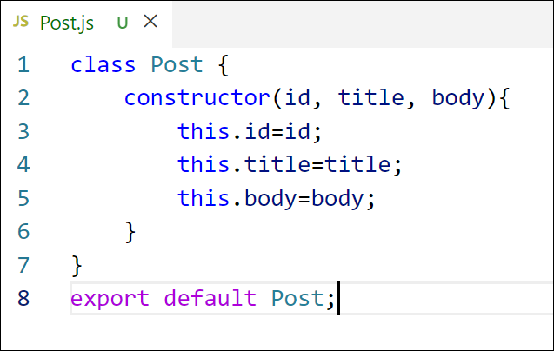

*Figure 2: Post class*

1. Create a new class based component named as **Posts** inside **Posts.js** file

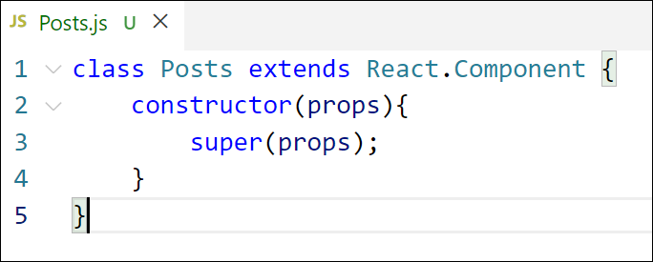

*Figure 3: Posts Component*

1. Initialize the component with a list of Post in state of the component using the constructor
2. Create a new method in component with the name as **loadPosts()** which will be responsible for using Fetch API and assign it to the component state created earlier. To get the posts use the url (<https://jsonplaceholder.typicode.com/posts>)

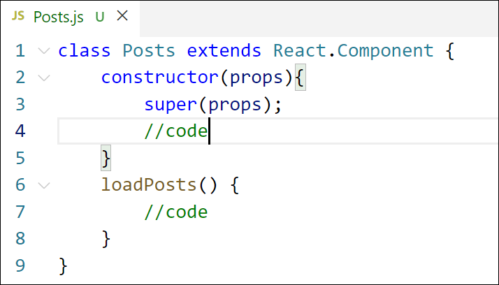

*Figure 4: loadPosts() method*

1. Implement the **componentDidMount()** hook to make calls to **loadPosts()** which will fetch the posts

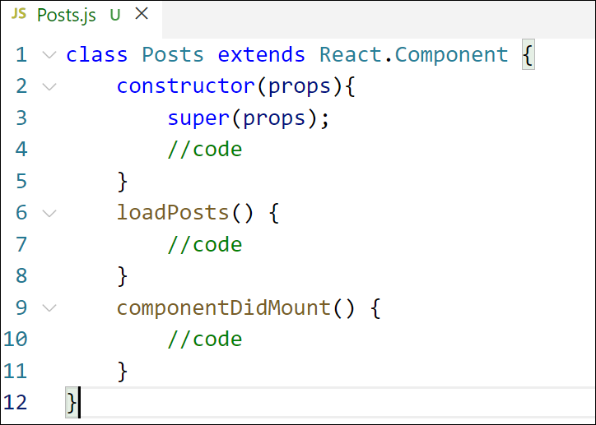

*Figure 5: componentDidMount() hook*

1. Implement the **render()** which will display the title and post of posts in html page using heading and paragraphs respectively.

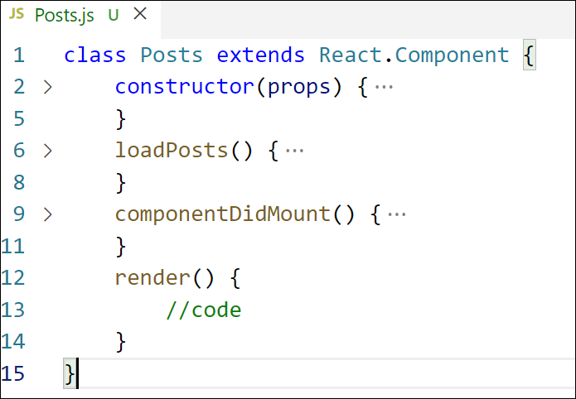

*Figure 6: render() method*

1. Define a **componentDidCatch()** method which will be responsible for displaying any error happing in the component as alert messages.

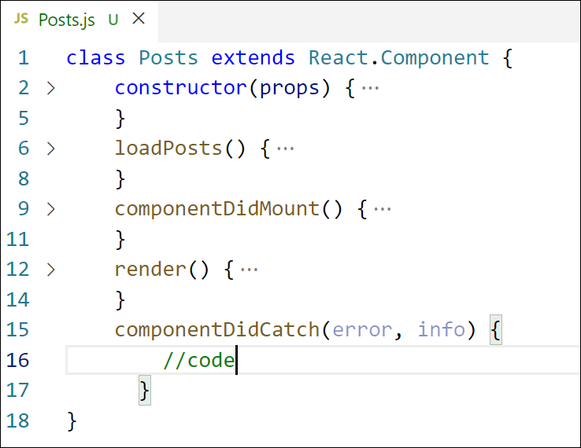

*Figure 7: componentDidCatch() hook*

1. Add the Posts component to App component.
2. Build and Run the application using *npm start* command.

## App.js:

import React from 'react';

import './App.css';

import Posts from './Posts';

function App() {

  return (

    <div className="App">

      <Posts />

    </div>

  );

}

export default App;

## Post.js:

class Post{

    constructor(id,title,body){

        this.id=id;

        this.title=title;

        this.body=body;

    }

}

export default Post;

## Posts.js:

class Posts extends React.Component {

  constructor(props) {

    super(props);

    this.state = {

      posts: []

    };

  }

  loadPosts() {

    fetch('https://jsonplaceholder.typicode.com/posts')

      .then((res) => res.json())

      .then((data) => {

        const postObjects = data.map((item) => new Post(item.id, item.title, item.body));

        this.setState({ posts: postObjects });

      });

  }

  componentDidMount() {

    this.loadPosts();

  }

  render() {

    return (

      <div>

        <h1>Blog Posts</h1>

        {this.state.posts.map((post) => (

          <div key={post.id}>

            <h3>{post.title}</h3>

            <p>{post.body}</p>

          </div>

        ))}

      </div>

    );

  }

}

export default Posts;

## Output:

